**My plan**

**Title : iStore**

Today there are many websites already there on internet but I am trying to make the website more simpler along with implementing all the basic features as well as trying to add new features as well.

**Objectives** :

To develop new ecommerce portal using different technologies using this site I want to make user to buy different product of apple Inc. initially I included macbook, iphone, ipad.

**Functionalities :**

If I discuss about functionalities of my e-commerce portal then I facilitate user to buy different product of Apple Inc. like..iPhone, iPad, Mac …and in future I am going to add other additional products and also planning to develop the feature of Appstore for the same.

Payment method is available either online or cash on delivery.

**Technologies :**

If I talk about technologies that I have used are..:

**Bootstrap:** to make my page responsive and could be able to take look and feel according to device and its resolution.

**AngularJS :** it’s a framework. Using angularJS I am using it to bind the values, flexibility with filter ,faster in execution and to make light weight application. And also to reuse the existing components.

**JavaScript:** To make my webpages Dynamic. It is client side scripting language so that I can make changes quickly within the user browser.

**H2 database :** it is comparatively lighter than other databases such as Oracle and SQL. It occupies very less memory for jar/dll

**Spring MVC :** now a days it is preferable to use MVC architecture to keep your project view, data, and controller separately so that it could be easy to modify that in future or to understand the overall working flow.

Spring is a framework that helps to wire different components together. It is most useful in cases where you have a lot of components and you might decide to combine them in different ways.

**Hibernate :** I used hibernate for database connectivity and to perform DB operations very easily using transactions of it

**JSON :** it is comparatively lighter then XML. Web services gives response in JSON format now a days rather than XML because Parsing is faster and removes unnecessary writing lengthy names of tag.

**HTML 5:** it’s the latest version of HTML that enables many unique features that older version doesn’t support. Like input type = email than we don’t have to put validations over there so its comparatively lighter and provides additional APIs such as.. window.performance,  [Network Information API](http://www.w3.org/TR/netinfo-api/) etc.

**CSS 3 :** Selectors, Box Model, Backgrounds and Borders, Image Values and Text Effects, 2D/3D Transformations, Animations, Multiple Column Layout.

**Maven :** it’s a built tool used to build jar and easy to build dependencies in our project. Using maven I have merged my frontend and backend projects.

**Apache tomcat 8:** its open source http web server that implements javaEE specifications like servlets,jsp ect.

**JQuery:** it’s a faster library of javascript. That is used to ..HTML document traversing, event handling, animating, and Ajax interactions for rapid web development.

**JavaEE:** The **Java EE** platform provides an API and runtime environment for developing and running large-scale, multi-tiered, scalable, reliable, and secure network applications

**Ecllipse Mars 2:** I used this IDE for entire java project development because it is flexible and Provides rich client platform and we don’t have to install it. And easily work with newer version.

**Moc designs**

**Landing page**

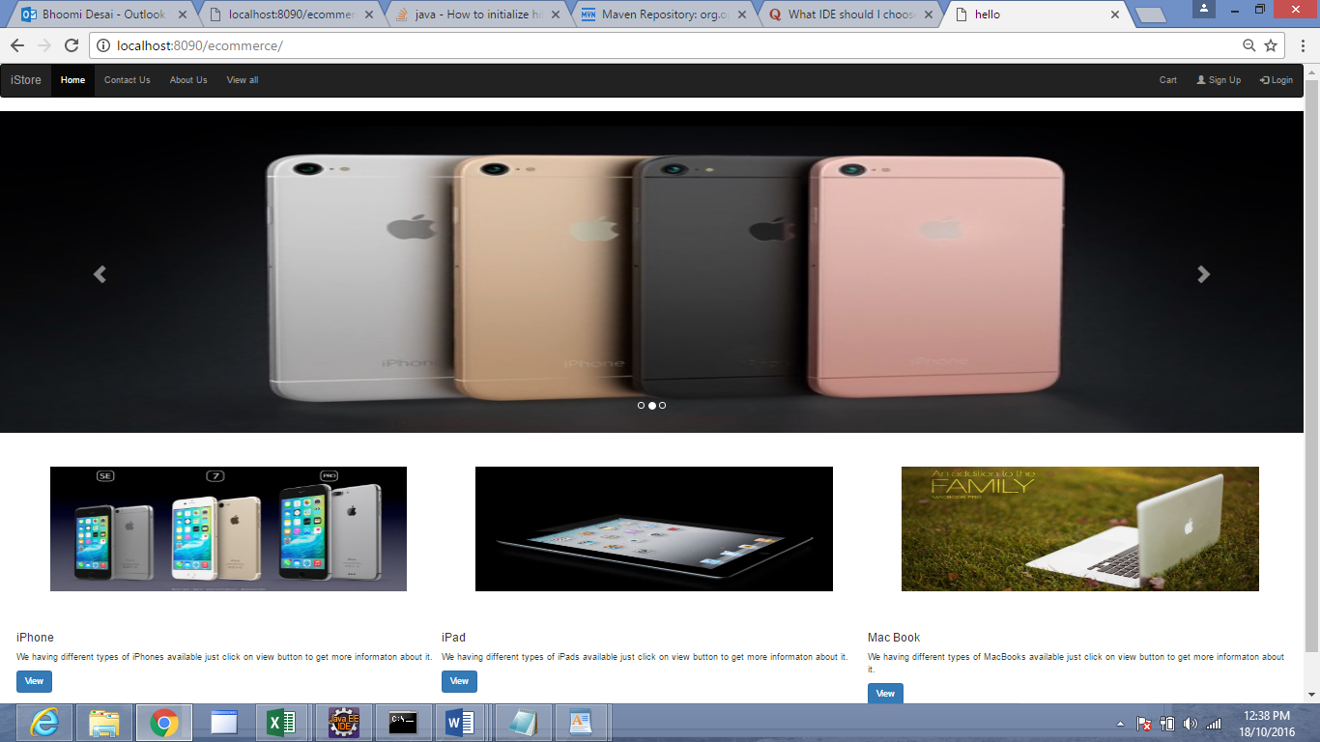

Shows basic information about product and GUI

**User login**

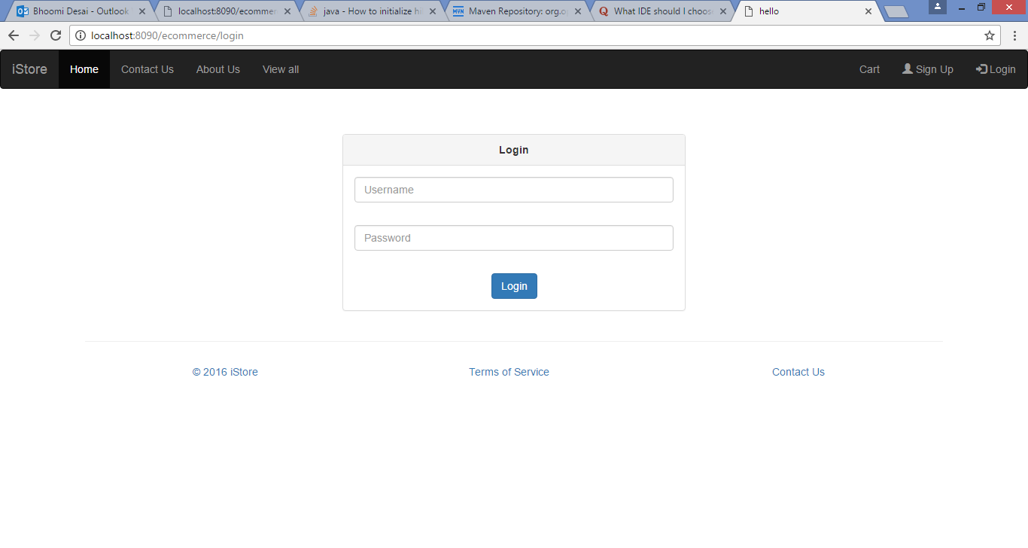

Has rights to purchase, view search product.

**Product Page**

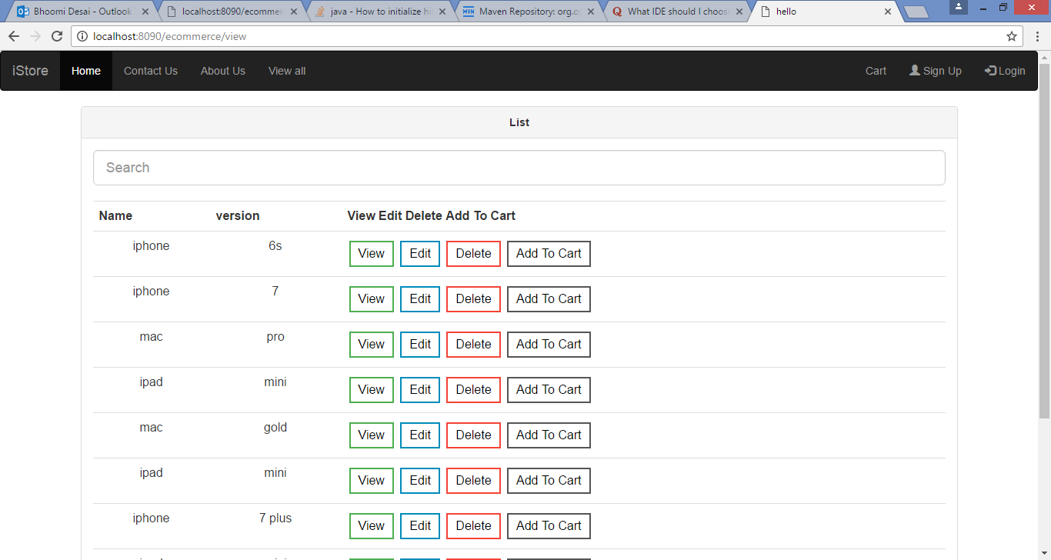

Can add / delete /edit and view product details.